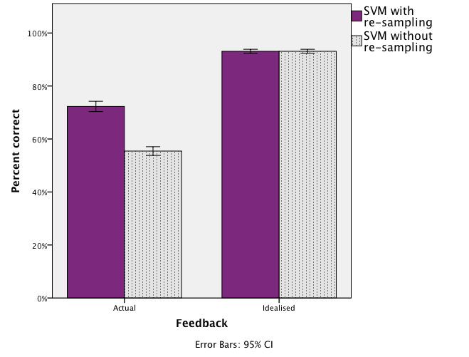

F(1,232)=222.5, p<.001